Interpolation of values within tetrahedron elements

Input:
x_{p}, y_{p}, z_{p} (coordinates of point P)
x_{e,1-4}, y_{e,1-4}, z_{e,1-4} (coordinates of element nodes 1-4)

Output:
w₁₋₄ (weight values 1-4 for nodal values)

Description:

Get local element coordinates (ξ-η-ζ system) ξ_{p}, η_{p}, ζ_{p} for coordinates of P:
Shape functions:
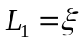
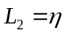
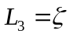
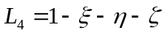

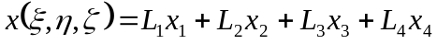
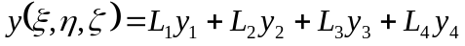
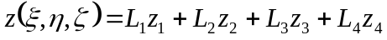

Get ξ_{p}, η_{p}, ζ_{p} for point P:
Solve the system:
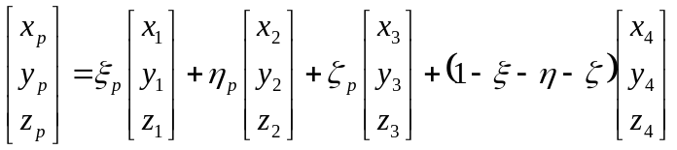
substituting the coordinates x_{p}, y_{p} and z_{p}.

It should hold that
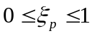
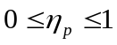
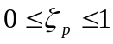
otherwise P is not within the element.

Calculate weight factors:
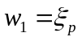
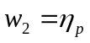
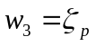
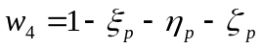

Given the result values r₁₋₄ in the nodes of the element, the result value r_{p} in point P can now be calculated using:
